City School District of the City of Niagara Falls
Instructional Technology Tool list
Program | Icon | Application | Grade(s) | Location, Student Username and Password | Recommended Session Time
Achieve 3000 Kidbiz or Teen Biz |  | English Language Arts | Kid Biz – 5 & 6  Teen Biz – 7 & 8 | Clever.com  UN: student #  PW: student # | 30 minutes per day
Brain Pop & Brain Pop Jr. |  | All subjects – short informational videos | Grades K - 8 | Clever.com  UN: student #  PW: student # | As desired – this site features short videos and mini-comprehension quizzes
Brain Pop Jr. | 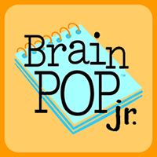 | All subjects – short informational videos | Grades K - 8 | Clever.com  UN: student #  PW: student # | As desired – this site features short videos and mini-comprehension quizzes
Castle Learning | 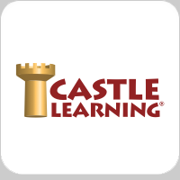 | High School core courses – English, Mathematics, Science and Social Studies | Grade 8 Math – Algebra I  Grades 9 – 12 | Clever.com  UN: student #  PW: student # | Session times vary by selected assignment
MobyMax |  | ELA  Math  Science  Social Science | Grades Kindergarten to 8 | Clever.com  UN: student #  PW: student # | 30 minutes per day
Reading Plus |  | ELA | Grades 7 & 8 AIS Students - only students enrolled in AIS classes have access | Clever.com  UN: student #  PW: student # | Approximately 45 minutes or as desired at home
Smarty Ants | 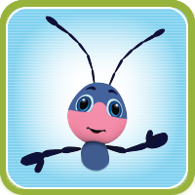 | ELA/ Language Arts | Grades Kindergarten to 2 | Clever.com  UN: student #  PW: student # | 3o minutes per day

Frequently Asked Questions:
Q: Where can I find my child’s student identification number?
A: Student ID numbers are 5 digits in length, and listed on each student’s report card
Q: How can I get to the Clever site?
A: The link below provides directions for locating Clever

